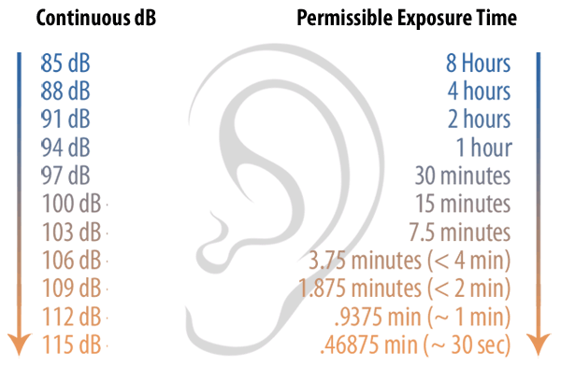
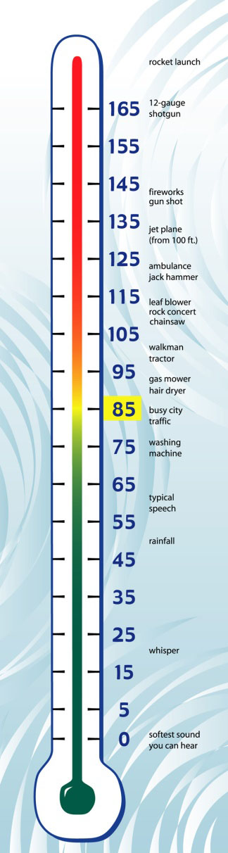
Decibel Exposure Time Guidelines
Information courtesy of Dangerous Decibels:
http://dangerousdecibels.org/education/information-center/decibel-exposure-time-guidelines/

